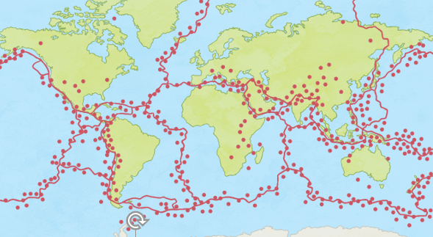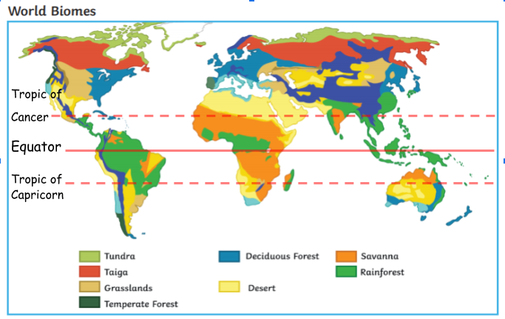

Climate Zones- What the weather is like over time in specific areas

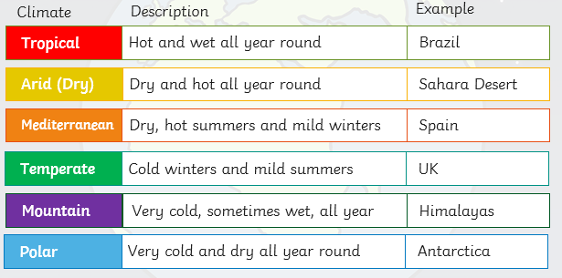

Tectonic plates - The earth’s crust is made up of large areas called tectonic plates that join together.

Biomes - areas of our planet with similar **climates**, **landscapes**, **animals** and **plants**

Through study of North America:

* Key aspects of physical geography: climate zones, earthquakes, volcanoes, biomes, mountain ranges, rivers
* Earthquakes are caused when tectonic plates move suddenly
* Earthquakes occur across North and South America
* Machines called **seismographs** measure the amplitude of an earthquake at its epicentre on a scale called the **Richter scale**

Earthquake hotspots:

Vocabulary

* Key aspects of physical geography: climate zones/vegetation belts/biomes (South America)
* Key geographical features of volcanoes

Year:6

Topic: North America/Earthquakes

What will I know by the end of this unit of work?

What should I already know?

Waterloo Primary School – Science Knowledge Organiser