

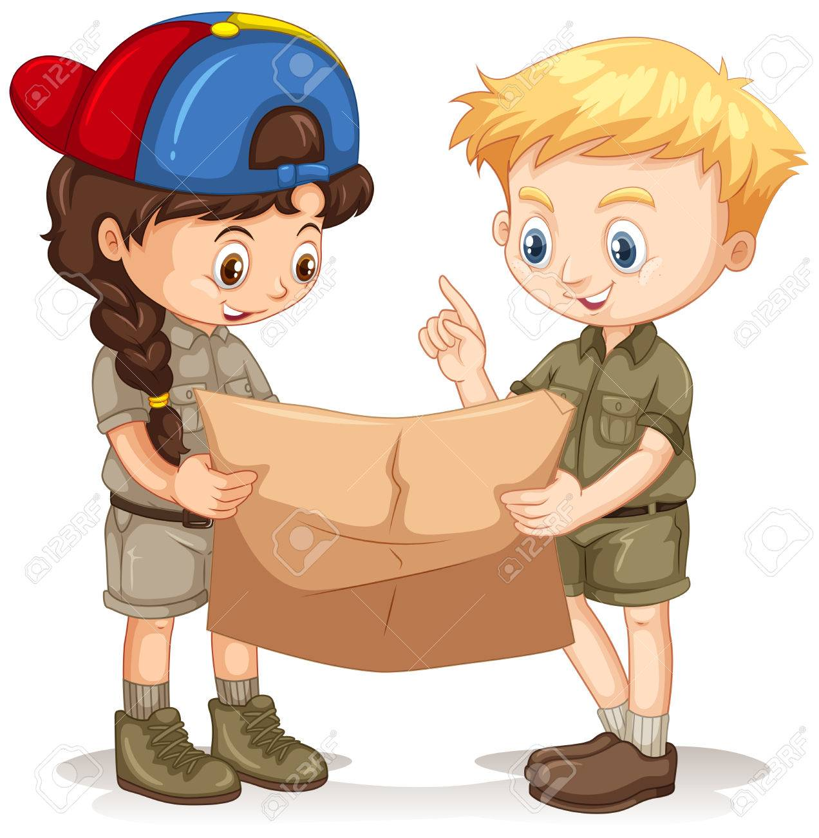

I will be able to:

* Use a simple picture map to move around the school
* Use directional language (near, far, up and down, left, right, forwards, backwards)
* Draw basic maps, including simple symbols and pictures to represent places or features (classroom/school grounds)
* Talk about the day-to-day weather and seasons in the UK
* Speak in front of a group/class when describing the weather

I will know that:

* In the UK, we have 4 seasons (autumn, winter, spring, summer).
* That our weather is changeable
* That autumn and winter have typical weather types
* That symbols are used to represent different weather types
* Map- A representation of an area of land and sea, showing main features such as cities and roads.
* Globe- Map of Earth.
* Location- Where something exists or can be found.
* Position – Where something is.

Locational language:

* Near
* Far
* Left
* Right
* Forwards
* Backwards

Ongoing seasonal vocabulary:

* Winter
* Spring
* Summer
* Autumn
* Cloudy
* Sunny
* Rainy
* Snowy
* Icy
* Windy

Where I live (Earth, UK, England, Liverpool)

That a globe is a map of our world.

How to describe different types of weather.

Vocabulary

Waterloo Primary School – Autumn Geography Knowledge Organiser

What will I know by the end of this unit of work?

Year: 1

Topic: Basic map skills/Seasons

What should I already know?