

Waterloo Primary School – Geography Knowledge Organiser

Year: 2

Topic: Map Skills

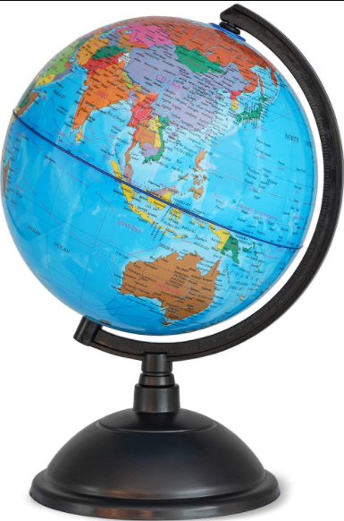

I will be able to:

* Identify continents and oceans using a globe, maps and atlases.
* Locate Sierra Leone and Nigeria
* Identify continents which have significant hot or cold areas and relate these to the Poles and Equator.

I will know:

* 7 continents: Europe, Antarctica, Australasia, Africa, North America, South America and Asia

* 5 oceans: Arctic, Atlantic, Pacific, Indian and Southern
* Equator – the great circle of the Earth that is equal distance from the poles, dividing the Northern and Southern hemispheres.
* Island – areas of land that are not connected to a continent and are surrounded by water.
* North Pole – the Northern hemisphere where the Earth’s axis of rotation meets the surface.
* South Pole – the Southern hemisphere where the Earth
* Ocean – vast expanse of water

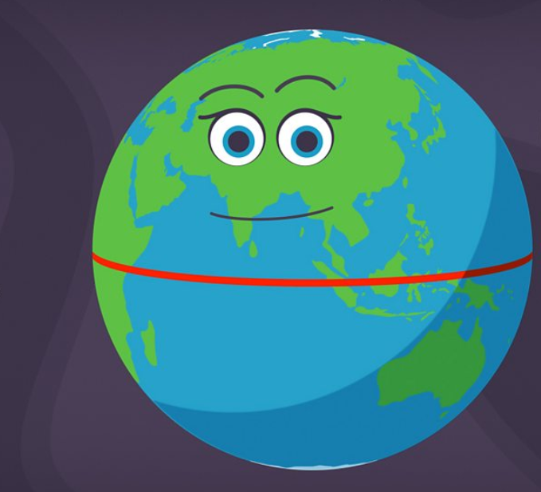

Vocabulary

* How to follow and make simple maps.
* Some human and physical features of our local area
* The four countries of the UK and capital cities
* The UK is surrounded by The North Sea, The Irish Sea and The English Channel
* We live in Europe

What will I know by the end of this unit of work?

What should I already know?