

Topic: Map Skills

Year: 2

Waterloo Primary School – Geography Knowledge Organiser

* Aerial photograph – photograph with bird’s eye view
* Compass - an instrument containing a magnetised pointer which shows direction
* Compass direction - North/South/East/West
* Docks – an enclosed area of water used for loading and unloading

Human Features:

Farm, port, docks, leisure centre, play area, shops, cafes

Physical Features:

Sea, ocean, river, sand dunes, beach

Vocabulary

* 4 countries of the UK, capital cities and surrounding seas
* 7 continents and 5 oceans
* Poles/equator: identify cold and warm regions including the equator
* Some human and physical features in our locality

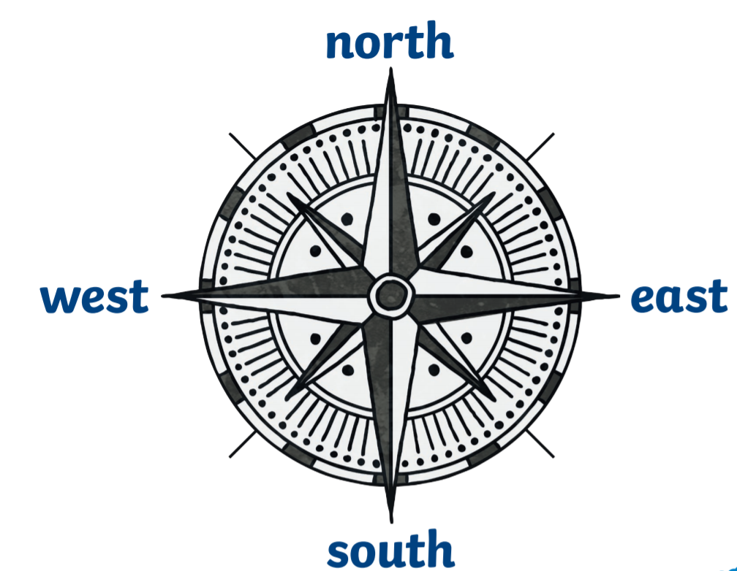

I will be able to:

* Follow a simple route map
* Begin to use compass directions (NSEW)
* Use aerial photographs to recognise human and physical features
* Draw or make a map with simple symbols and a key (Marina/park/lakeside/lake…)

I will know:

* Basic map and compass skills using directional language in the locality.
* Describe locational features and routes in the locality.
* Use aerial photographs and planned perspectives.
* Recognise human and physical features in the locality.
* Follow a route on a map (route to Marina)
* Begin to use simple compass directions (North, South, East, West) to describe location of features and routes
* Use aerial photographs and plan perspectives to recognise landmarks and basic human and physical features

*Map knowledge:*

* Locate and name on a world map and globe the seven continents and five oceans.
* Locate Sierra Leone and Benin

*Making maps:*

* Draw or make a map with simple symbols and a key (Marina/park/lakeside/lake…)
* Identify seasonal and daily weather patterns in the UK and which continents have significant hot or cold areas and relate these to the Poles and Equator.
* Understand geographical similarities and differences through studying the human and physical geography of a small area of UK and a small area of a non-European country (Waterloo in Liverpool and Sierra Leone)

What will I know by the end of this unit of work?

What should I already know?