

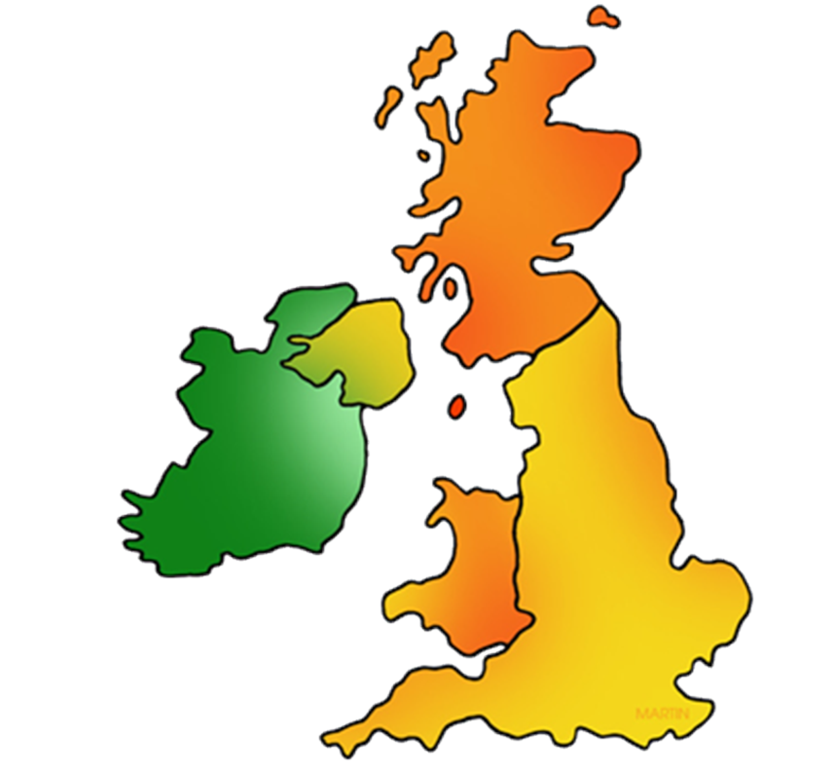

I will be able to:

* locate Liverpool on a map of England
* Locate the capital cities of the United Kingdom on a map.
* Use world maps and atlases to identify the UK and its position in the world/including locating Europe
* Describe the local environment using geographical vocabulary linked to human features
* Follow a route map of an unknown area

I will know:

* I live in the United Kingdom
* The UK is made up of England, Northern Ireland, Scotland and Wales
* The capital of England is London
* The capital of Northern Ireland is Belfast
* The capital of Scotland is Edinburgh
* The UK is in Europe
* Some typical weather types for Spring
* Some human features of our local area (roads/train station/shops/library…)

What will I know by the end of this unit of work?

Map- A representation of an area of land and sea, showing main features such as cities and roads.

Globe- Map of the Earth.

Location- Where something is or can be found.

Human features- things built by humans (shop, library, church, road, house, office, train station)

Continent- any of the world's main continuous expanses of land. A group of countries

Country- a nation with its own government

City -  an area in which a large number of people live fairly close together.

Ongoing seasonal vocabulary:

* Winter
* Spring
* Summer
* Autumn
* Cloudy
* Sunny
* Rainy
* Snowy
* Icy
* Windy

Vocabulary

In the UK, we have 4 seasons

Some typical weather types for autumn and winter

How to follow and make a simple map of our classroom.

What should I already know?

Topic: Map skills/Local area/Human features/Seasons

Year: 1

Waterloo Primary School – Spring Geography Knowledge Organiser