

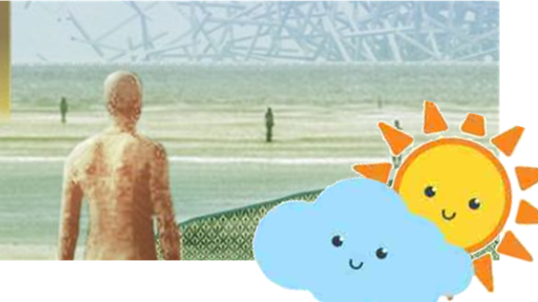

I will be able to:

* Use photographs and maps to identify features
* Talk about the day-to-day weather and seasons in the UK
* Describe the local environment using geographical vocabulary
* Identify human and physical features of our local area.

I will know that:

Our local area is made up of human and physical features:

* Shops
* Library
* Churches
* Roads
* Offices
* Train station
* Beach
* Sand dunes
* Sea

These features are represented on maps.

Location- Where something exists or can be found.

Physical features- features that are naturally on the Earth due to the power of the planet. Humans did not make them e.g. beach, coast, sea, hill.

Liverpool- The city we live in.

Ongoing seasonal vocabulary:

* Winter
* Spring
* Summer
* Autumn
* Cloudy
* Sunny
* Rainy
* Snowy
* Icy
* Windy

Vocabulary

* The continent, nation, country and city that I live in
* How to follow a simple route map
* We have four seasons
* Typical weather conditions for autumn, winter and spring
* Human features are made by humans

Waterloo Primary School – Spring Geography Knowledge Organiser

Year: 1

Topic: Local area/Physical features/Seasons

What should I already know?

What will I know by the end of this unit of work?