

* How to locate Sierra Leone on a map
* That localities have human and physical features
* Human and physical features of our local area

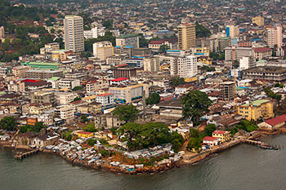

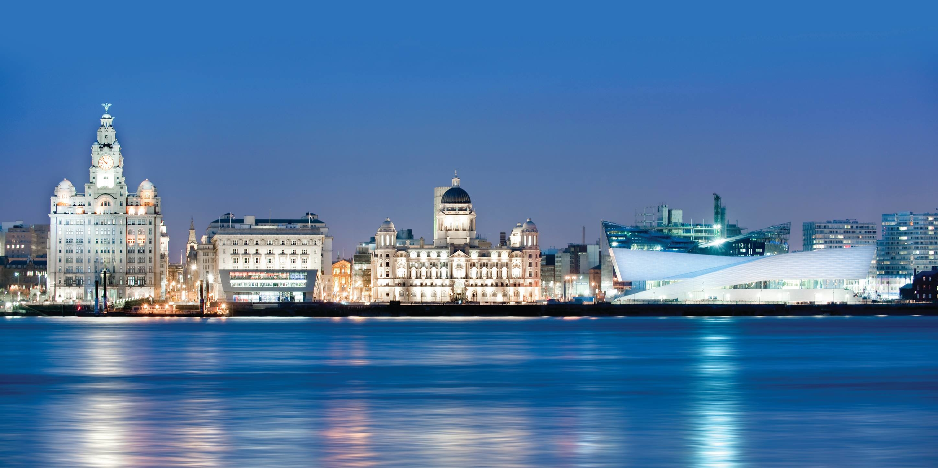

I will be able to:

* Use maps, atlases and aerial photographs to identify human and physical features of Sierra Leone
* Compare these features to our local area
* Make some comparisons between life in Waterloo here and life in Waterloo in Sierra Leone

I will know:

* Sierra Leone is in West Africa
* Waterloo is the second largest city in Sierra Leone
* Sierra Leone is recovering from war
* The weather is Sierra Leone is different to here
* There are some similarities and some differences in the lives of children here and the lives of children there.

Bird’s eye view/Aerial view – a photograph taken from an aircraft or satellite in flight.

Human features - Features that have been made by humans e.g. shops and houses

Physical features - Features that occur naturally such as rivers and mountains

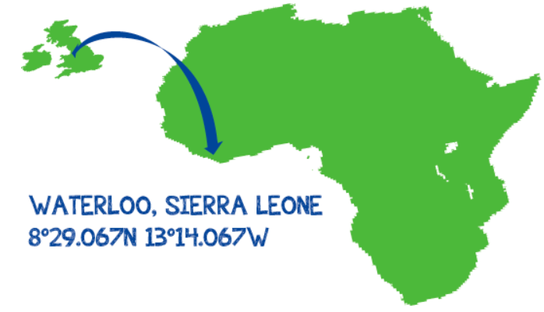

Vocabulary

What will I know by the end of this unit of work?

What should I already know?

Year: 2

Topic: Waterloo in Liverpool and Waterloo in Sierra Leone

Waterloo Primary School – Geography Knowledge Organiser