

Topic: Map skills, UK counties/cities, Europe

**Atlas** - book of maps

**Country** - an area of land that is controlled by its own government

**County** - a specific region of a state or country

**Digital map** - an electronic map

**Continent** - a very large area of land that consists of many countries

**City** - a large town e.g. London

**Europe** - a continent located entirely in the Northern Hemisphere and mostly in the Eastern Hemisphere

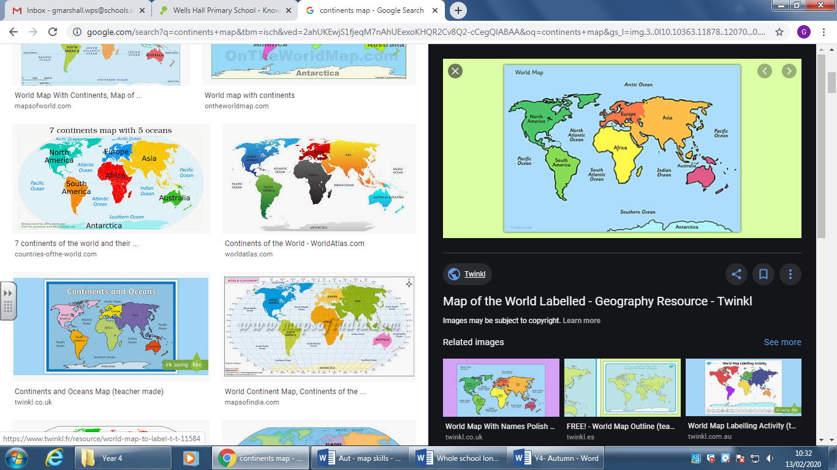

Vocabulary

* The 4 countries of the UK, their characteristics, capital cities and surrounding seas
* Sierra Leone and Nigeria are located within the continent of Africa.
* The 7 continents and 5 oceans

Year: 3

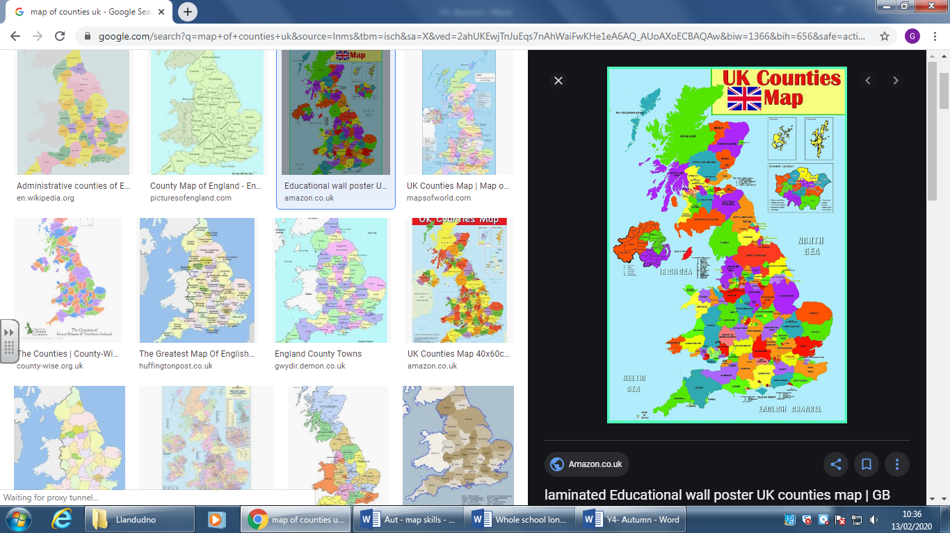 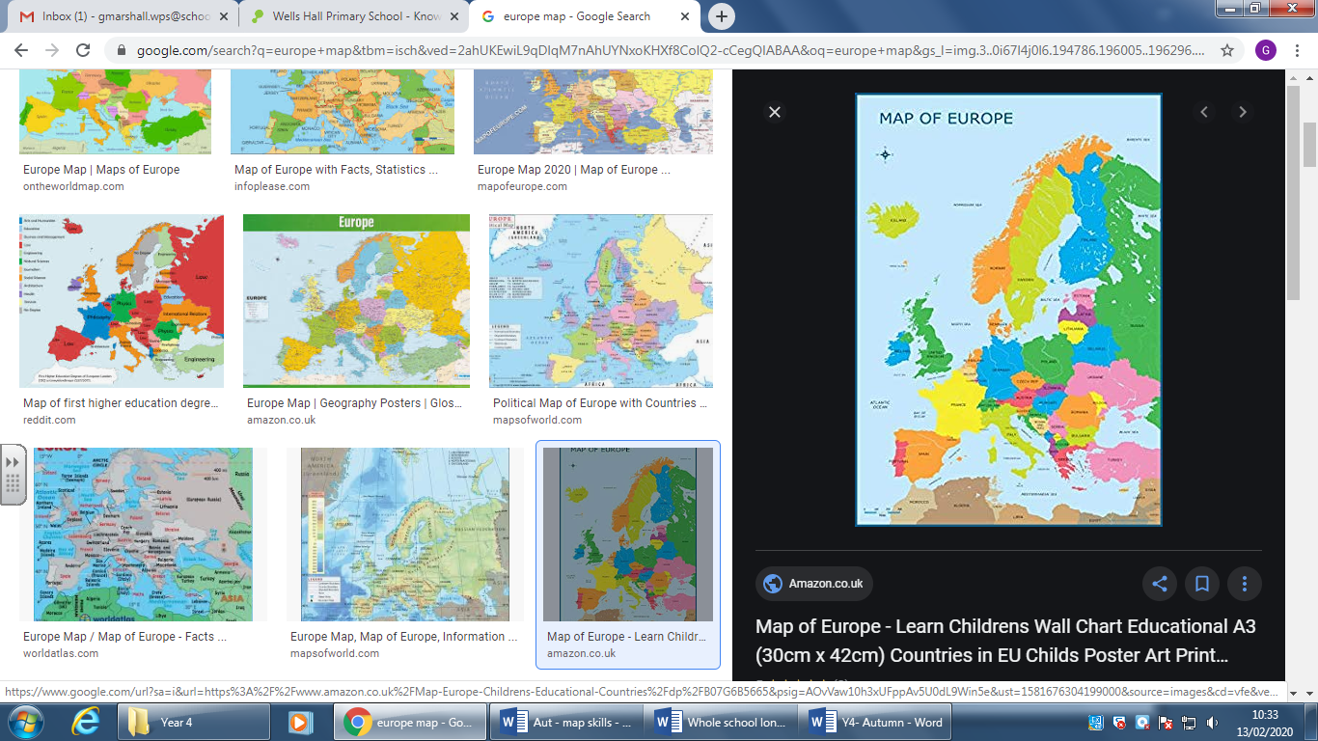

I will be able to:

* Locate UKs countries and counties using different scales of maps including digital maps
* Locate Europe and an increasing number of countries within Europe (Spain, Greece, UK)
* Use the terms: continent, country, county, city to describe where we live
* Begin to use 4 figure grid references

I will know:

* We live in Liverpool.
* Liverpool is a city in Merseyside
* Merseyside is a county in England
* England is one of 4 countries in the UK
* The UK is in Europe, there are many countries in Europe including: Spain and Greece

What will I know by the end of this unit of work?

What should I already know?

Waterloo Primary School – Geography Knowledge Organiser