

Topic: Llandudno and Waterloo – human and physical features

Year: 3

**Compass points** - the main points of a compass: north, south, east, west.

**4-figure grid reference** – contains 4 numbers. The first two numbers are called the **easting**, which is the number you would look for at the bottom of the map. The second two numbers are called the **northing** and represent the numbers you would look for on the side of the map.

**settlement** - a place, typically one which has previously been uninhabited, where people establish a community.

**land use** – the function of land – what it’s used for.

**trade** - the activity of buying, selling or exchanging goods and services.

**human features** - features of land that have been impacted by human activity.

**physical features** - natural features of land.

Vocabulary

* A range of physical and human features of our local area
* How to use aerial photographs and plan perspectives to recognise landmarks and basic human and physical features
* How to describe the physical and human features of Sierra Leone and Nigeria
* That life can be different in different locations

I will be able to:

* Use 4-figure compass points (NSEW) and grid references (letter/number co-ordinates)
* Use geographical vocabulary when making comparisons

I will know:

* Some human features of Llandudno
* (shops, cinema, theatre, hotels, prom, mine)
* Some physical features of Llandudno (beach, bay, mountain)
* Some similarities and differences between Llandudno and our local area (land use, jobs, buildings, settlements, trade links)

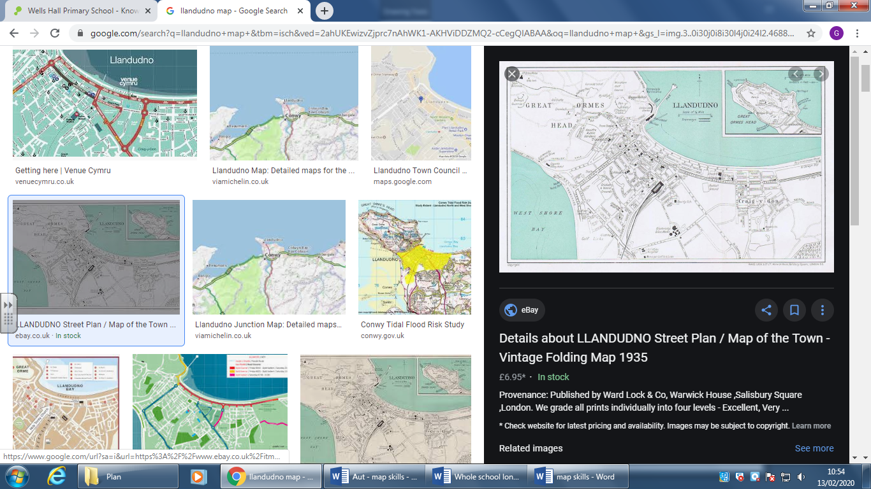

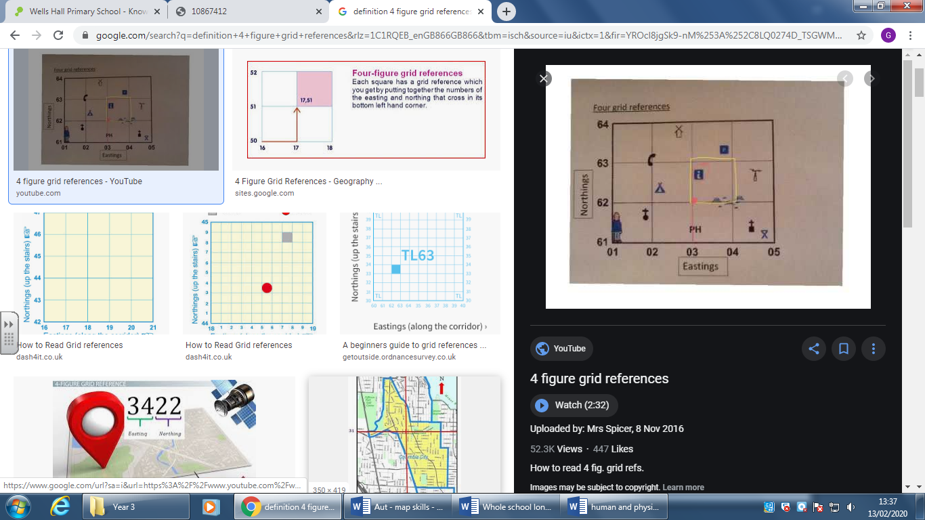

What will I know by the end of this unit of work?

What should I already know?

Waterloo Primary School – Geography Knowledge Organiser