
Equator – a line notionally drawn on the earth equidistant from the poles, dividing the earth into northern and southern hemispheres and constituting the parallel of latitude 0°
Poles – Either of the points at which the Earth's axis of rotation intersects the Earth's surface - North Pole or South Pole
Northern Hemisphere – the half of the earth that is north of the equator
Southern Hemisphere – the half of the earth that is south of the equator
Biome – a large naturally occurring community of flora and fauna occupying a major habitat, e.g. forest or tundra
Vegetation Belt – An area of the planet characterised by certain flora (plants) due to climatic conditions
Mountain – a large natural elevation of the earth's surface rising abruptly from the surrounding level; a large steep hill
Alpine – high mountain
Avalanche - a mass of snow, ice, and rocks falling rapidly down a mountainside
Altitude – great height
Crevasse - a deep open crack in a glacier
Drainage – removal of water
Elevation – raising something to a higher level
Erosion – when material is worn away from the Earth’s surface

Vocabulary
which continents have significant hot or cold areas and how to relate these to the Poles and Equator.
Topic: Map skills, Equator, Poles, Hemispheres, Biomes, Vegetation Belts and Mountains
Year: 3
What should I already know?
I will be able to:
- Use maps and globes with increasing independence
- Use geographical vocabulary
I will know: 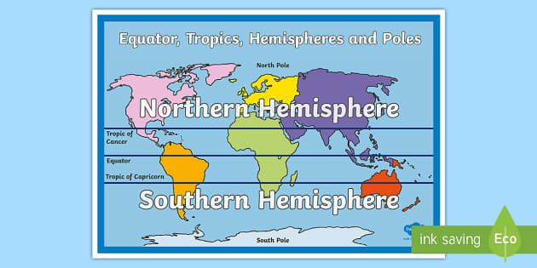
- The position of equator/poles/northern and southern hemisphere
- Key aspects of: biomes, vegetation belts and mountains.
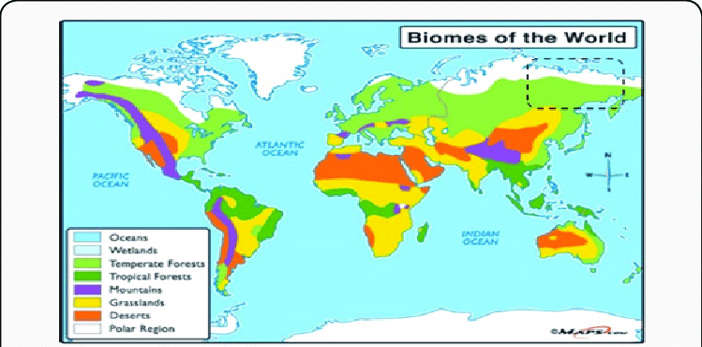
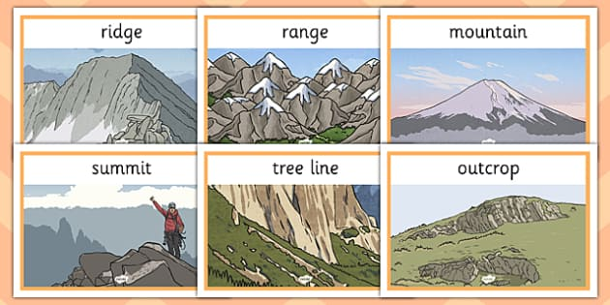

What will I know by the end of this unit of work?
Waterloo Primary School – Geography Knowledge Organiser

