

Continent- 7 large areas make up land on Earth. These are known as continents

Ocean- Each of the main areas in which the sea is divided geographically

Map- A representation of an area of land and sea, showing main features such as cities and roads

Globe- The Earth

Human feature- Characteristics of a place that come from human ideas and actions e.g. houses, roads etc

Physical feature- Natural characteristics of a place e.g. mountains, rivers etc

Location- Where something exists or can be found

Compass directions - North, East, South, West

Ordnance Survey (OS) – National Mapping Agency

Vocabulary

* The UK is made up of 4 countries, each with a capital city
* Merseyside is a county in England
* Liverpool, Chester and Rome are cities
* Simple compass directions

Topic: Countries, Counties and Cities

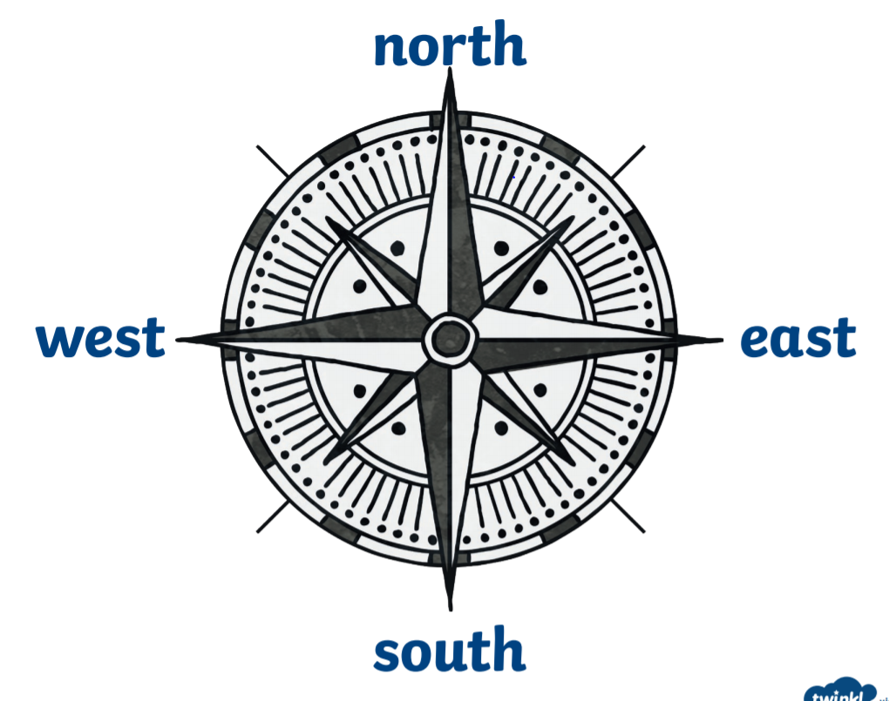

I will be able to locate:

* Cities within England, such as Liverpool and Chester
* Some counties of the UK e.g. Merseyside, Cheshire, Lancashire, Dublin and Conway
* Countries of the world (World Cup participants)
* Use simple compass directions to describe locations

I will know:

* Some similarities and difference between Liverpool and Chester

OS symbols are used to show the locations of features on a map.

|  |  |
| --- | --- |
| Parking | Cathedral |
| Museum | Art Gallery |

What will I know by the end of this unit of work?

Year: 4

What should I already know?

Waterloo Primary School – Geography Knowledge Organiser