
Ancient - belonging to the very distant past and no longer in existence.
Archaeologist - someone who studies the past by exploring old remains
Common Era - a method of numbering years which refers to the period of time that began after the birth of Jesus Christ
Century – 100 years
Chronological – order in which events occurred
Emperor – a sovereign ruler of an empire
Invader - a person or group that invades a country, region, or other place
Source - a place, person, or thing from which something originates or can be obtained
Significance - the quality of being worthy of attention; importance

Irrigation – movement of water to farmland

Empire – group of countries ruled by one monarch or ruler

Trade – buying/selling/exchanging.
Vocabulary
I will be able to:
- Use timelines to place events in order (intervals of 10/100/1000)
- Use words century/decade
- Use evidence to describe past
- Describe similarities and differences between people, events and objects
- Show changes on a timeline
- Look at 2 versions of the same event and identify differences
- Use pictures or objects to find information about the past
I will know that:
- The River Nile is in Egypt. Egypt is in Africa
- Ancient Egypt was before the year 0 on a timeline and is therefore BC
- They had pharaohs for leaders and Tutankhamen is the most famous
- Ancient Egyptians build pyramids
- The Ancient Egyptians build an empire

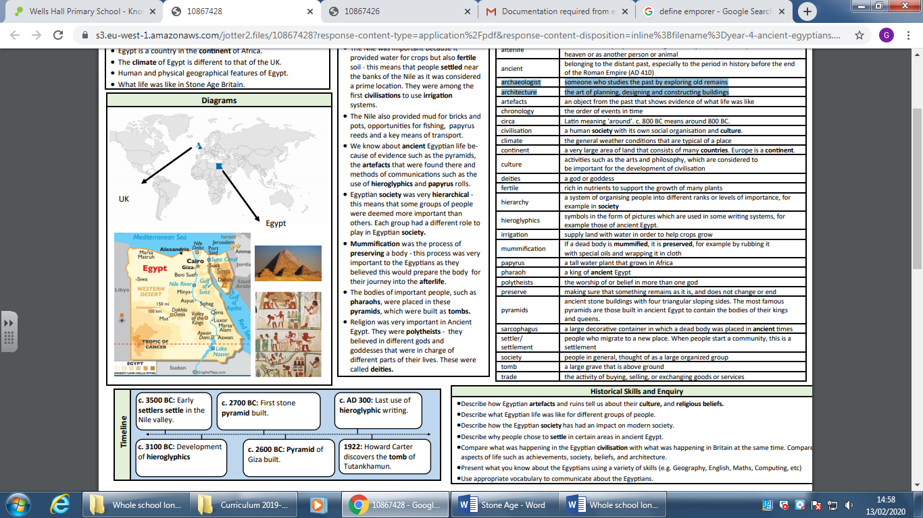
- Timelines can be divided into BC and AD
- How Ancient Egypt fits on a timeline
What will I know by the end of this unit of work?
Topic: Ancient Egypt
Year: 3
What should I already know?
Waterloo Primary School – History Knowledge Organiser

