

* Timelines can be divided into BC and AD
* How Ancient Greece fits on your timeline

Vocabulary

**Ancient -** belonging to the very distant past and no longer in existence.

**Archaeologist** - someone who studies the past by exploring old remains

**Common Era** - a method of numbering years which refers to the period of time that began after the birth of Jesus Christ

**Century** – 100 years

**Chronological** – order in which events occurred

**Duration -** the time during which something continues

**Emperor** – a sovereign ruler of an empire

**Invader -** a person or group that invades a country, region, or other place

**Source -** a place, person, or thing from which something originates or can be obtained

Democracy – a system of government where leaders are elected through votes

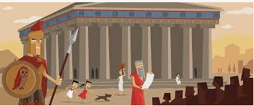

**I will be able to:**

* Use timelines to place events in order (intervals of 10/100/1000)
* Use words century/decade
* Use evidence to describe past
* Describe similarities and differences between people, events and objects
* Show changes on a timeline
* Use pictures or objects to find information about the past
* Use dates and terms with increasing accuracy

**I will know:**

* Ancient Greece was before the year 0 so is classed as BC on a timeline
* Democracy first occurred in Ancient Greece
* The Olympics and the marathon were founded in Ancient Greece
* The Ancient Greeks traded with other kingdoms
* How the Ancient Greeks travelled and transported goods
* About Ancient Greek settlements and way of life

What will I know by the end of this unit of work?

Topic: Ancient Greece

Year: 3

What should I already know?

Waterloo Primary School – History Knowledge Organiser