

* How to order key events on a timeline
* That I can learn about the past in different ways

Topic: Transport now and then

What should I already know?

Vocabulary

A long time ago – far in the past

Decades – a period of ten years

Evidence – proof that something is right or true

Timeline – a representation of a period of time, on which important events are marked.

Century – 100 years

Penny Farthing – old bike

Invention – a design/creation of something new

Chariot – a 2 wheeled vehicle, drawn by horse

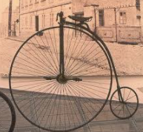

**I will be able to:**

Talk about some differences between modern and old transport

**I will know:**

* The building of the railway changed things in our local area (became easier to visit family, created more jobs, safer than cars, easier to visit new places, easier to transport goods, ruins countryside views, dangerous to be near trains, noisy, created pollution)
* Know that George Stephenson was known as the ‘Father of Railways’ due to his inventions
* Be able to order significant events in the development of transport
* Ancient Romans build road in Britain and travelled in chariots
* Vikings travelled in ships powered by oars

What will I know by the end of this unit of work?

Strand: History

Waterloo Primary School – History Knowledge Organiser

Year:2