

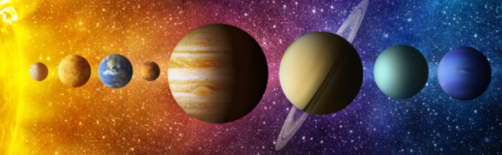

**I will be able to:**

* Order events chronologically
* Use tense correctly when talking about events
* Recount main points from a significant event

**I will know:** 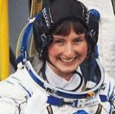

* Tim Peake is a British astronaut
* Helen Sharman was the first British person into space.
* Neil Armstrong was the first
* The first animal in space was a dog called Laika

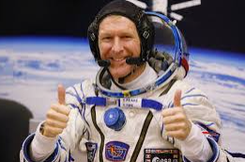

Decades – a period of ten years

Evidence – proof that something is true

Timeline – a representation of a period of time, on which important events are marked.

Astronaut – a person who is trained to travel in a spacecraft

Voyage – journey

Solar system – collection of planets which orbit the sun

Moon – natural satellite

* Transport has changed over time
* We live on Earth; Earth is a planet within our solar system
* Technology is advancing with time

Vocabulary

What should I already know?

What will I know by the end of this unit of work?

Strand: History

Waterloo Primary School – History Knowledge Organiser

Year:2

Topic: The Space Race