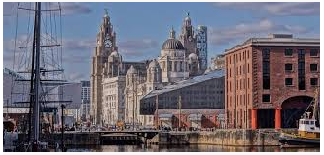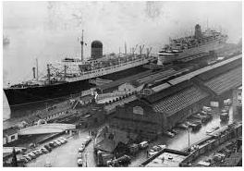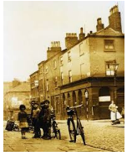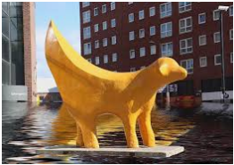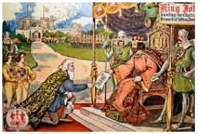

By the end of this unit of work, I will know:

* The key events in the history of Liverpool and how to design my own timeline to sequence them
* Some social, cultural, religious and ethnic diversities of societies in Britain (immigration)
* Some causes and consequences of the main events, situations, and changes in Liverpool, such as: poverty, trade and immigration.
* Give reasons for changes to Liverpool and make links within and across periods studied
* Use printed sources, the internet, databases, pictures, photos, music, artefacts, history building, and visits to collect information about the history of Liverpool.

What have been the most significant events in the history of Liverpool?

Investigate

**Trade - the act of exchanging or buying and selling goods.**

**Trade route** - one of the sea-lanes ordinarily used by merchant ships. – a route followed by traders

**Slave** - The practice. of people owning other people

Nation - a people living in the same region of the world and having a common history, language, and culture

Cause - something or someone that brings about a result or effect

Consequence – a result or effect of an action

Democracy - a form of government in which power rests with the people, either directly or through elected representatives

Immigration - the act of coming to live permanently in a new country.

Evidence - something that gives proof or a reason to believe

Primary source - A document or object that was created during the time period being studied. A person who was there could be a primary source

Vocabulary

* Liverpool is a large city in the United Kingdom of Great Britain and Northern Ireland (formerly Britain)
* The industrial revolution was a time of great change across Britain
* Britain has changed considerably over time.

What should I already know?

What will I know by the end of this unit of work?

Waterloo Primary School – History Knowledge Organiser

Year 5

Topic: Liverpool