
Titanic – a cruise ship that sank in 1912
Voyage – journey
Artefact – an object from the past
Maiden Voyage – the first journey a ship makes
Significant - important
New York – the city in America that the Titanic was sailing to
Southampton – the city in England the Titanic sailed from
Iceberg - A huge block of ice floating in the sea
Captain - Someone in charge of the ship
Unsinkable - Impossible to sink
Lifeboat - A small, emergency boat
Vocabulary
- How to order some events or objects on a timeline
- I can learn about the past in different ways
I will be able to:
- Sequence events in order
- Find answers to different questions
I will know:
- The Titanic was a cruise ship that sank on 15th April 1912 after hitting an iceberg
- The Titanic was described as “unsinkable.”
- The Titanic was on its first ever voyage from Southampton to New York
- On the Titanic there were 3 different classes: first, second and third class. First class was for rich people whilst third class was for poor people
- The Titanic’s Captain was called Edward John Smith
- Women and children were loaded onto the lifeboats first
- There were not enough lifeboats for everybody
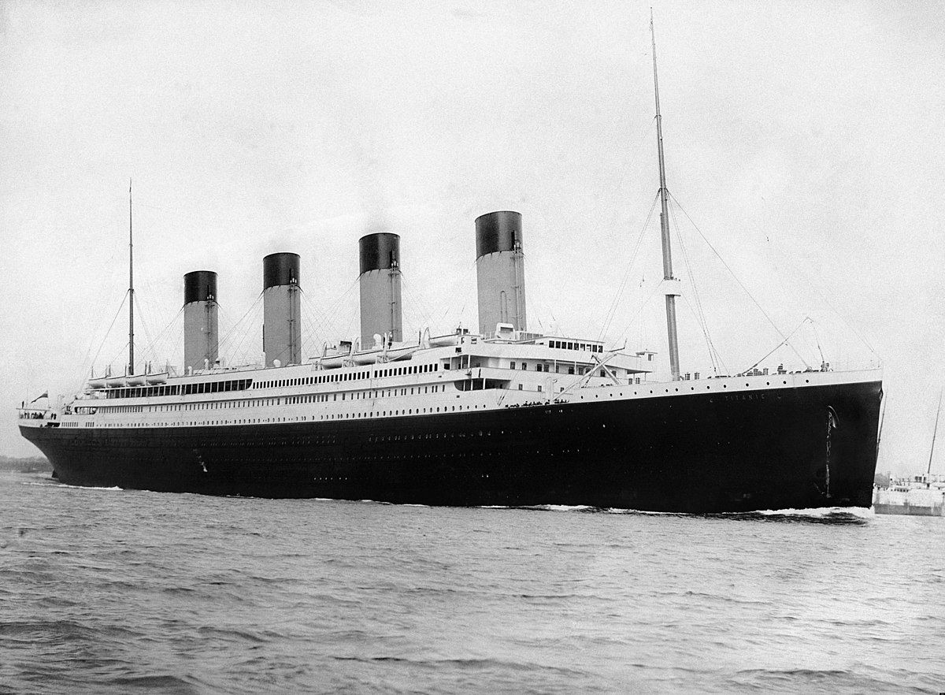
What should I already know?
What will I know by the end of this unit of work?
Strand: History
Waterloo Primary School – History Knowledge Organiser
Year:1
Topic: Titanic

