

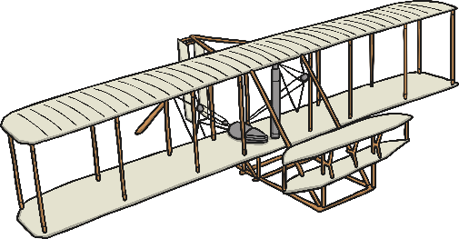

**I will be able to:**

Order objects and events dating back more than 100 years

**I will know:**

* Some differences between the Wright flyer and a modern plane.
* The Wright brothers changed the aviation through their inventions.
* The first flight taken by the Wright brothers was in November 1903 and lasted 12 seconds.
* Changes in aviation led to changes in holidays
* Amelia Earhart was the first female to fly across the Atlantic Ocean in 1928 and completed her first solo trip in 1932

Decades – a period of ten years

Evidence – a sign or something that shows that something exists or is true.

Timeline – a representation of a period of time, on which important events are marked.

Aviation – flight/use of an aircraft

Invention – Design/creation of something new

Tourism – holidays and travel for fun/interest

* Transport and technology have changed over time
* People travel for a variety of reasons
* We can learn about the past in different ways

Vocabulary

What should I already know?

What will I know by the end of this unit of work?

Strand: History

Waterloo Primary School – History Knowledge Organiser

Year:2

Topic: History of flight