

Conflict – a struggle or clash between opposing forces, often resulting in battle.

Evidence – provides us with information about the past. Evidence can take many forms such as primary and secondary evidence.

Settlement – a city, town or village where people live and work.

Invasion – entering a country with an army.

Chronology - events or dates in the order they occurred

Amphitheatre – an open curved building with seat around the edge

Forum – centre of a Roman city

Centurion – leader of a unit of Roman Legion

Archaeologist - a person who studies history by excavating historical sites

Legacy – the lasting impact of an era

Empire – a group of states or countries ruled by a single leader

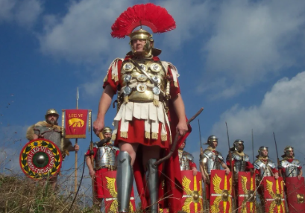

**I will be able to:**

* Use timelines to place and sequence events
* Conduct research in order to answer questions
* Use different sources of evidence to justify my answers

**I will know:**

* In 55BC Julius Caesar led an invasion of Britain. The Celts fought them off
* In 54BC Caesar invaded again – the Celts were forced to pay them in order to continue their way of life
* In 43 AD Emperor Claudius led a successful invasion, gaining full control of Britain
* AD60 Boudicca led a failed rebellion
* The Roman’s traded throughout Empire
* Chester was a Roman settlement
* The legacy of Roman Britain can be see today

Topic: Romans

What will I know by the end of this unit of work?

Vocabulary

Timeline from Year 3 (Stone Age to Iron Age, Ancient Egypt and Ancient Greece)

We can learn from different historical sources

Ancient Romans built roads and travelled in chariots (Year 2)

Year: 4

What should I already know?

Waterloo Primary School – History Knowledge Organiser