

* How to order events chronologically
* That we learn about the past using different sources of evidence

Vocabulary

**Common Era** - a method of numbering years which refers to the period of time that began after the birth of Jesus Christ

**Century** – 100 years

**Chronological** – order in which events occurred

**Bronze Age -** a prehistoric period that followed the Stone Age and preceded the Iron Age, when weapons and tools were made of bronze rather than stone.

**Hunter-gatherer -** a member of a nomadic people who live chiefly by hunting and fishing, and harvesting wild food

**Duration -** the time during which something continues

**Invader -** a person or group that invades a country, region, or other place

**Iron Age -** a prehistoric period that followed the Bronze Age, when weapons and tools came to be made of iron

**Stone Age -** a prehistoric period when weapons and tools were made of stone or of organic materials such as bone, wood, or horn.

**Source -** a place, person, or thing from which something originates or can be obtained

**Significance -** the quality of being worthy of attention; importance.

**I will be able to:**

* Use timelines to place events in order (intervals of 10/100/1000)
* Use words century/decade
* Use evidence to describe past
* Describe similarities and differences between people, events and objects
* Show changes on a timeline
* Look at 2 versions of the same event and identify differences
* Use pictures or objects to find information about the past
* Use dates and terms with increasing accuracy

**I will learn about:**

* Timelines can be divided into BC and AD
* The stone age began 4 million years ago
* The stone age came first, followed by the bronze age and finally came the iron age
* What the terms stone, bronze and iron age mean
* The earliest people were hunters who adapted to become farmers
* Money was invented as another form of trading

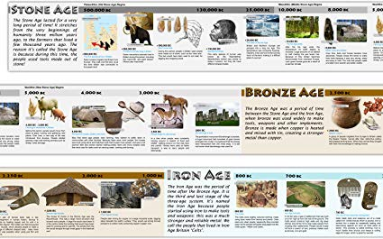

What will I know by the end of this unit of work?

Topic: Stone Age to Iron Age

Year: 3

What should I already know?

Waterloo Primary School – History Knowledge Organiser