
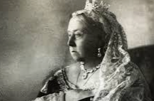
I will be able to:
Add the Victorian era to timeline beginning with the Stone Age
Select reliable sources to answer questions
I will know:
Poor children often worked in dangerous conditions.
Queen Victoria’ s era coincides with the peak years of the British Empire.
Queen Victoria believed that education should be for all, and by the end of her reign, going to school became compulsory for all children, rich or poor.
Healthcare saw huge improvements under the Victorians. Medical pioneers like Florence Nightingale worked with the government to improve hospital cleanliness — which hadn’t been considered as important before!
The Victorian era saw huge developments in industry and transport
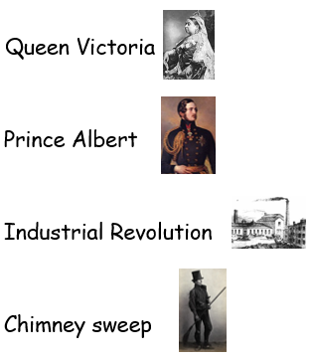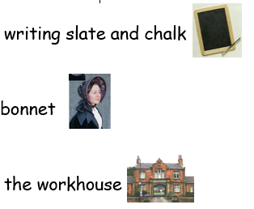
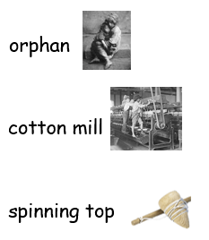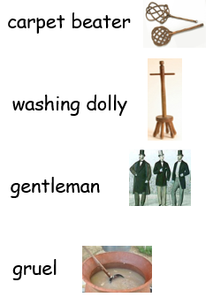
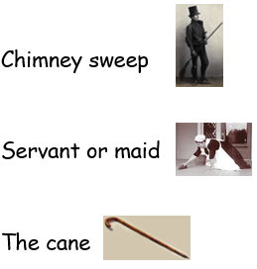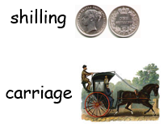
Vocabulary
An Empire is a group of countries or states with one ruler
Use timelines with intervals of 10/100/1000 years, appreciating the length of different historical periods
Topic: The Victorians
Year: 5
What should I already know?
What will I know by the end of this unit of work?
Waterloo Primary School – History Knowledge Organiser

