

Slave– someone who is property of another person and must obey them. The Vikings enslaved people on their journeys around Europe and the British Isles.

King Alfred the Great – King of Wessex and later the King of the Anglo-Saxons. He successfully defended his kingdom against the Vikings.

Longboat – long sail boats made from wood. The Vikings chosen method of transport.

Warrior – a brave and experiences soldier or fighter.

Raid – a surprise attack on an enemy. The Vikings carried out many raids in Britain before settling here.

Democracy – government controlled by the whole population, often through voting and electing representatives.

Justice – fair behaviour or treatment. For example, undertaking a penalty for committing a crime.

Trade Route – the long distance taken to transport goods, for selling and buying.

Vocabulary

* Once the Romans had left Britain at around 410AD, the Anglo-Saxons arrived in tribes from Germany, Denmark and the Netherlands.
* The Anglo-Saxons were asked to come to Britain to defend the country from attacking Picts and Scots.

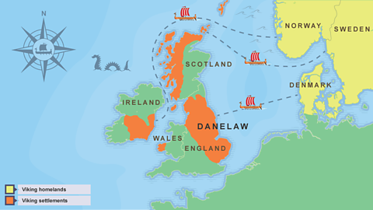

**I will be able to:**

* Use timelines to place and sequence events
* Conduct research in order to answer questions
* Consider why the Vikings raided Britain
* Use deduction skills, like an archaeologist
* Explain why sources may have been biased

**I will know:**

The Viking age was around 700-1100 AD.

During this time Vikings left their homes in Scandinavia and travelled by longboats to Britain

The Vikings were fierce warriors and fought local people, stealing from churches and burning down buildings

The Vikings carried out many raids on Britain before trying to conquer the land in 865AD. They battled for many years across England, taking control of Anglo-Saxon villages.

By 874AD almost all of the kingdoms had fallen to the Vikings.

Topic: Vikings

What will I know by the end of this unit of work?

Year: 4

What should I already know?

Waterloo Primary School – History Knowledge Organiser