19.7.24

Dear parent and carers,

Change of class teacher from September 2024

I am writing to advise you that your child will be taught by Miss Saunders, who is currently teaching in Year 3, for the next school year. This is due to some staffing changes within the school. Miss Saunders is an excellent teacher who has impressed us this year working alongside Mr Donoghue. She has been taking his Year 3 class during his absence. This has resulted in her successful appointment to the teaching staff.

We will be arranging for Miss Saunders to meet your child on Monday morning.

Miss Robinson, who was due to move to Year 3, will now be teaching within Year 6 and also will be working for the North West Maths Hub over the next year. She will not have full class responsibility.

With very best wishes for the summer break.

Yours sincerely,

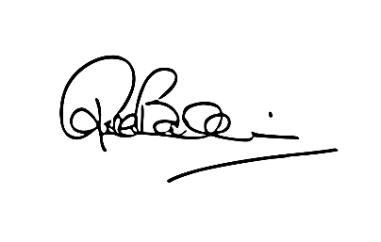

Mrs R Baldwin

Headteacher