
- That I can make responsible choices in school
- That there I are people I can to for help
- That rules are important
Know how individual attitudes and actions make a difference to my class
Know about the different roles in my school community
Know my place in our school community
Know what democracy is (School Council)
Know that my actions affect myself and others
Know how groups work together to reach a consensus
Know that having a voice and democracy benefits the school community
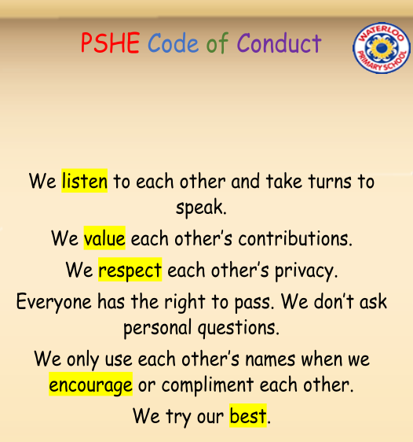
Included/Excluded
Welcome
Valued
Role
Job Description
School Community
Responsibility
Rights
Democracy
Democratic
Reward
Consequence
Decisions
Voting
Authority
Contribution
Observer
UN Convention on Rights of Child (UNCRC)
Vocabulary
Topic: Being Me in My World
Year:4
Autumn 1
What should I already know?
What will I know by the end of this unit of work?
Waterloo Primary School – PSHE Knowledge Organiser

