

Personal

Sperm

Egg

Penis

Testicles

Vagina

Vulva

Womb/Uterus

Ovaries

Fertilise

Puberty

Periods/Menstruation

Vocabulary

Some of the ways our bodies change as we grow which prepare us for having babies

Who I can talk to if my body isn’t being respected by someone

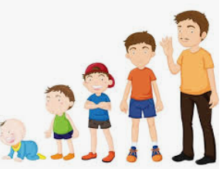

Know the names of the different internal and external body parts that are needed to make a baby

Know how the female and male body change during puberty

Know that personal hygiene is important during puberty and as an adult

Know that change is a normal part of life and that some cannot be controlled and have to be accepted

Know that change can bring about a range of different emotions

Topic: Changing Me

Year:4

Summer 2

What should I already know?

What will I know by the end of this unit of work?

Waterloo Primary School – PSHE Knowledge Organiser