

Value

Leader/Follower

Assertive

Agree/Disagree

Smoking

Pressure

Peers

Guilt

Advice

Alcohol

Liver

Disease

Anxiety

Believe

Opinion

Right/Wrong

Vocabulary

* Know who to go to if I feel unsafe
* Know I can make healthy life choices
* Know that different drugs can be helpful or harmful

Know which friends I value and why

Know that there are leaders and followers in groups

Know the facts about smoking and its effects on health

Know some of the reasons some people start to smoke

Know the facts about alcohol and its effects on health, particularly the liver

Know some of the reasons some people drink alcohol

Know ways to resist when people are putting pressure on me

Know what I think is right and wrong

I understand the importance of brushing my teeth thoroughly

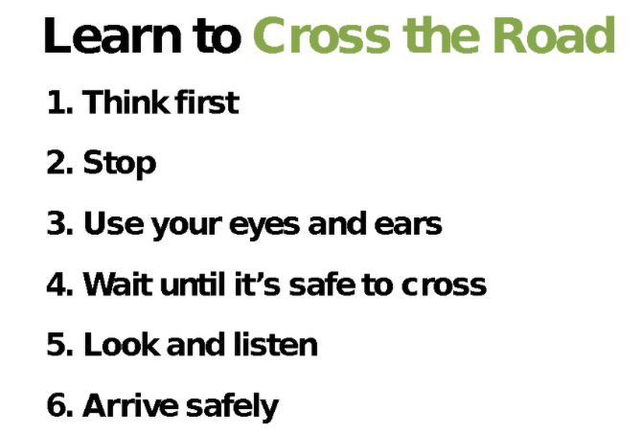

Topic: Healthy Me

Year:4

Spring 2

What should I already know?

What will I know by the end of this unit of work?

Waterloo Primary School – PSHE Knowledge Organiser