

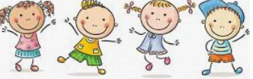

Know some reasons why people feel jealousy

Know that jealousy can be damaging to relationships

Know that we all experience feelings of loss

Know that loss is difficult to cope with and that some negative feelings are normal

Know that memories can support us when we lose a special person or animal

Know that change is a natural part of relationships/ friendship

Know that sometimes it is better for a friendship/ relationship to end if it is causing negative feelings or is unsafe

Jealousy

Loss

Shock/Disbelief

Numb

Denial

Guilt

Despair

Sentimental

Memorial

Acceptance

Relief

Negotiate

Compromise

Loyal

Empathy

Betrayal

Amicable

Appreciation

Vocabulary

That some of the things we buy affect the livelihoods of others

Topic: Relationships

Year:4

Summer 1

What should I already know?

What will I know by the end of this unit of work?

Waterloo Primary School – PSHE Knowledge Organiser