

* The importance of listening within our community
* What it means to be democratic
* Know how to face new challenges positively
* Know how to set personal goals
* The rights and responsibilities associated with being a citizen in the wider community and my country
* Know how an individual’s behaviour can affect a group
* How democracy and having a voice benefits the school community
* The age of criminal responsibility is 10

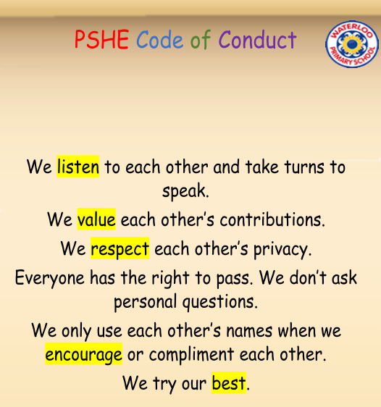

Ghana/West Africa

Cocoa Plantation

Cocoa Pods

Machete

Rights/Wants/Needs

Community

Maslow

Empathy

Comparison

Opportunities

Responsibilities

Cooperation

Collaboration

Legal/Illegal

Participation

Motivation

Democracy

Vocabulary

Topic: Being Me in My World

Year:5

Autumn 1

What should I already know?

What will I know by the end of this unit of work?

Waterloo Primary School – PSHE Knowledge Organiser