
- Know what culture means
- Know that differences in culture can sometimes be a source of conflict
- Know what racism is and why it is unacceptable
- Know that rumour spreading is a form of bullying on and offline
- Know external forms of support in regard to bullying e.g. Childline
- Know that bullying can be direct and indirect
- Know how my life is different from the lives of children in the developing world
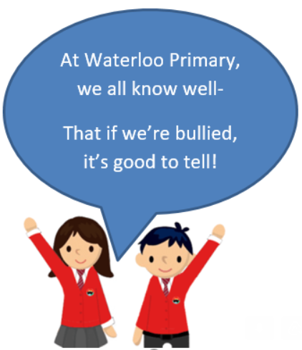
Culture
Conflict
Race/Racism/Racist
Discrimination
Rumour
Homophobic
Cyber bullying
Indirect/Direct bullying
Developing World

Vocabulary
- First impressions aren’t always right.
- What to do if I witness bullying of any kind
Topic: Celebrating Difference
Year:5
Autumn 2
What should I already know?
What will I know by the end of this unit of work?
Waterloo Primary School – PSHE Knowledge Organiser

