

Body-image

Affirmation

Body parts: uterus/womb, oestrogen, fallopian tube, cervix, breasts, vagina, vulva, hips, penis, testicles, Adam’s apple, scrotum, genitals, foreskin, ovaries

Puberty/changes: hair, broader, wider, sperm, semen, erection, ejaculation, urethra, wet dream, growth spurt, larynx, hormones, scrotum, testosterone, ovum, periods, menstruation

Circumcised/Uncircumcised

Fertilised/Unfertilised

Conception: sexual intercourse

Embryo

Umbilical cord

IVF

Foetus

Contraception

Pregnancy

Hygiene

Vocabulary

Some of the ways our bodies change as we grow which prepare us for having babies

Who I can talk to if my body isn’t being respected by someone

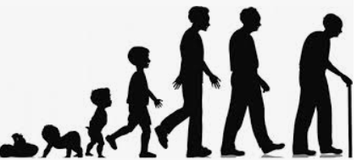

Know what perception means and that perceptions can be right or wrong

Know how girls’ and boys’ bodies change during puberty

Know the importance of looking after myself physically and emotionally

Know that sexual intercourse can lead to conception

Know that some people need help to conceive and might use IVF

Know that becoming a teenager involves various changes and also brings growing responsibility

Topic: Changing Me

Year:5

Summer 2

What should I already know?

What will I know by the end of this unit of work?

Waterloo Primary School – PSHE Knowledge Organiser