

* Know that a personality is made up of many different characteristics, qualities and attributes
* Know that belonging to an online community can have positive and negative consequences
* There are rights and responsibilities in an online community or social network
* Know that there are rights and responsibilities when playing a game online
* Too much screen time isn’t healthy
* Know how to stay safe when using technology to communicate with friends

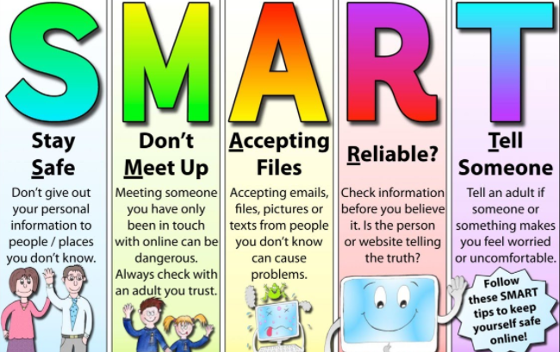

Personal attributes/characteristics

Negative self-talk

Social media

Social network

Gaming

Grooming

Troll

Gambling/ Betting

Screen time

Physical health/mental health

Peer pressure

Influences

SMART rules

Vocabulary

Know there are different ways to help deal with loss

Topic: Relationships

Year:5

Summer 1

What should I already know?

What will I know by the end of this unit of work?

Waterloo Primary School – PSHE Knowledge Organiser