

I know that we have rules, rights and responsibilities to make our community fairer

* Know how to set goals for the year ahead
* Know about children’s universal rights (United Nations Convention on the Rights of the Child)
* Know that my personal choices can affect others locally and globally
* Know how democracy and having a voice benefits our school community
* Understand how to contribute towards the democratic process

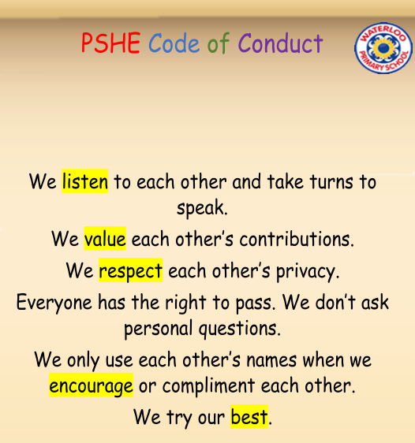

Challenge

Goal

Attitude

Actions

Rights and Responsibilities

United Nations Convention on The Rights of the Child

Citizen

Choices

Consequences

Views

Opinion

Collaboration

Collective Decision

Democracy

Vocabulary

Topic: Being Me in My World

Year:6

Autumn 1

What should I already know?

What will I know by the end of this unit of work?

Waterloo Primary School – PSHE Knowledge Organiser