

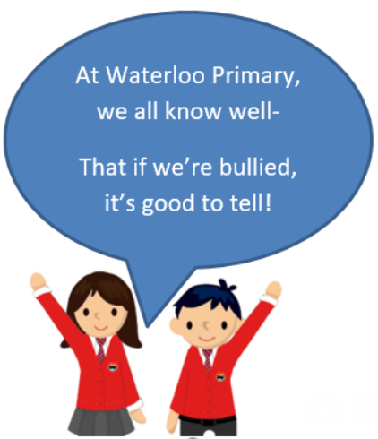

* Know that there are different perceptions of ‘being normal’ and where these might come from
* Know that being different could affect someone’s life
* Know that power can play a part in a bullying or conflict situation
* Know that people can hold power over others individually or in a group
* Know why some people choose to bully others
* Know that people with disabilities can lead amazing lives
* Know that difference can be a source of celebration as well as conflict

Ability

Disability

Visual impairment

Blind

Empathy

Perception

Medication

Diversity

Transgender

Gender Diversity

Harassment

Para-Olympian

Accolade

Perseverance

Stamina

Vocabulary

* I know that difference can be the cause of bullying
* I know what indirect and direct bullying are

Topic: Celebrating Difference

Year:6

Autumn 2

What should I already know?

What will I know by the end of this unit of work?

Waterloo Primary School – PSHE Knowledge Organiser