

Perception

Self-esteem

Affirmation

mental health

midwife/labour

Hygiene

Age appropriateness

Legal/Laws

Attraction

Sexting

Transition

Body parts: uterus/womb, oestrogen, fallopian tube, cervix, breasts, vagina, vulva, hips, penis, testicles, Adam’s apple, scrotum, genitals, foreskin, ovaries

Puberty/changes: hair, broader, wider, sperm, semen, erection, ejaculation, urethra, wet dream, growth spurt, larynx, hormones, scrotum, testosterone, ovum, periods, menstruation

FGM: Female Genital Mutilation

Vocabulary

Some physical and emotional changes that occur during puberty

When it is appropriate to take about private body parts, puberty and sex

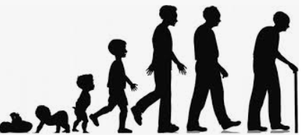

Know how girls’ and boys’ bodies change during puberty

Know the importance of looking after myself physically and emotionally

Know how a baby develops from conception through the nine months of pregnancy and how it is born

Know how being physically attracted to someone changes the nature of the relationship

Know the importance of self-esteem and what I can do to develop it

Know what I are looking forward to and what I am worried about when thinking about transition to secondary school

Topic: Changing Me

Year:6

Summer 2

What should I already know?

What will I know by the end of this unit of work?

Waterloo Primary School – PSHE Knowledge Organiser