

Immunisation/Vaccination

Prevention

Prescribed/Over-the-counter

Restricted/Unrestricted

Legal highs

Exploited

Vulnerable

Crime/Criminal

County lines

Reputation

Anti-social behaviour

Mental illness

Managing stress

Terrorism

Extremism

Radicalisation

Vocabulary

I know that people can have healthy and unhealthy relationships with food

* I Know how to take responsibility for my own health and wellbeing
* I Know about different types of drugs and their uses
* I know that some people (including children) can be exploited and made to do things that are against the law
* I know some ways to keep myself safe from exploitation
* I Know why some people join gangs and the risk that this can involve
* I know that stress can be triggered by a range of things
* I know how to travel safely

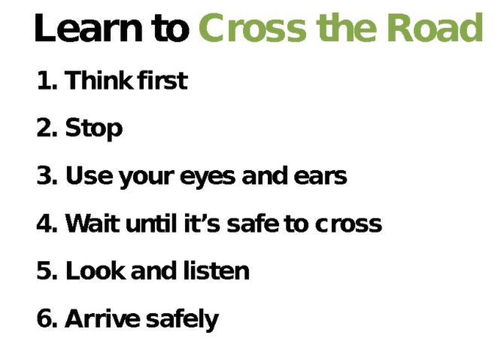

Topic: Healthy Me

Year:6

Spring 2

What should I already know?

What will I know by the end of this unit of work?

Waterloo Primary School – PSHE Knowledge Organiser