

I know why my class is a safe place

I know we all have rights and responsibilities

I know my hopes and fears for the year ahead

I know the rights and responsibilities myself and my class members have

I know that it is important to listen to other people

I know that my views are valuable

I know about rewards and consequences

I know that my actions can impact on others

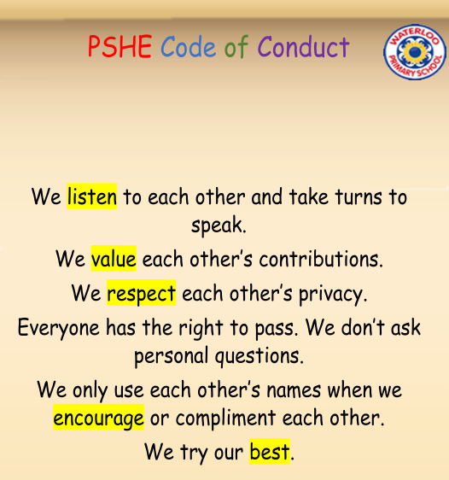

Worries

Hopes

Fears

Belonging

Rights/Responsibilities

Actions

Praise/Reward

Consequence

Positive/Negative

Choices

Co-Operate

Problem-Solving

Vocabulary

Topic: Being Me in My World

Year:2

Autumn 1

What should I already know?

What will I know by the end of this unit of work?

Waterloo Primary School – PSHE Knowledge Organiser