

I know there are stereotypes about boys and girls

I know that we don’t have to conform to these gender stereotypes

I know it’s good to be myself

I know that sometimes people get bullied because of difference

I know the difference between right and wrong and the role that choice has to play in this

I know that friends can be different and still be friends

I know where to get help if I am being bullied or I witness bullying

I know the difference between a one-off incident and bullying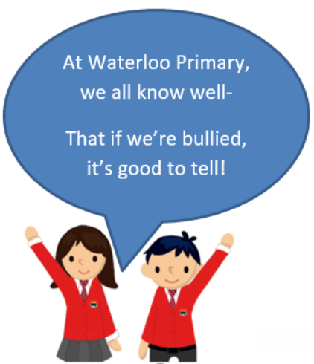

Gender

Boys/Girls

Similarities/Differences Assumptions

Shield

Stereotypes

Purpose

Lonely

Stand up for

Male/Female

Diversity

Fairness

Kindness

Unique

Value

Incident

Vocabulary

I know we are all different

I know how to report bullying

Topic: Celebrating Difference

Year:2

Autumn 2

What should I already know?

What will I know by the end of this unit of work?

Waterloo Primary School – PSHE Knowledge Organiser