

* That may behaviour can impact on other people in my class
* That choices can have good and bad consequences

Know that I can set personal goals and challenges

Know why rules are needed and how these relate to choices and consequences

Know that actions can affect others’ feelings

Know that others may hold different views

Know our school code of conduct

Know I have personal strengths

Know that I and others experience feelings of happiness, sadness, worry and fear

Know how to make others feel valued

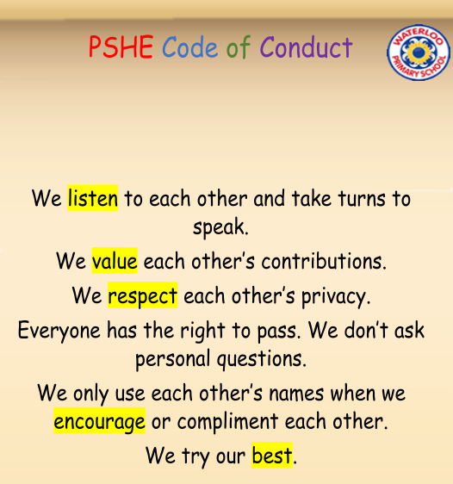

Welcome

Valued

Achievements

Personal Goal

Acknowledge

Affirm

Emotions

Nightmare

Worries

Solutions

Support

Rights/Responsibilities

Rewards/Consequences

Fairness

Choices

Co-Operation

Group Dynamics

Team work

Vocabulary

Topic: Being Me in My World

Year:3

Autumn 1

What should I already know?

What will I know by the end of this unit of work?

Waterloo Primary School – PSHE Knowledge Organiser