

Know why families are important

Know that everybody’s family is different

Know that sometimes family members don’t get along and some possible reasons for this

Know that conflict is a normal part of relationships

Know what it means to be a witness to bullying and that a witness can make the situation worse

Know that some words are used in hurtful ways and that this can have consequences

Know how to use the ‘Solve it together’ technique to calm and resolve conflicts with friends and family

Know how to give and receive compliments

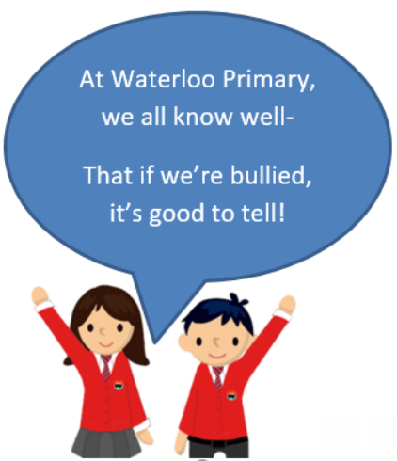

Loving

Caring

Safe

Connected

Difference

Conflict

Solve It Together

Solutions

Resolve

Witness

Bystander

Gay

Consequences

Compliment

Unique

Vocabulary

* That my friend and I have similarities and differences
* Know what bullying is and how to report it

Topic: Celebrating Difference

Year:3

Autumn 2

What should I already know?

What will I know by the end of this unit of work?

Waterloo Primary School – PSHE Knowledge Organiser