

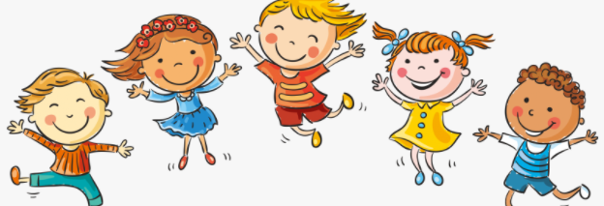

Know that in animals and humans lots of changes happen between conception and growing up

Know that in humans a mother carries the baby in her uterus (womb) and this is where it develops

Know that babies need love and care from their parents/carers

Know some of the changes that happen between being a baby and a child

Know that the male and female body needs to change at puberty so their bodies can make babies when they are adults

Know some of the outside body changes that happen during puberty

Know some of the changes on the inside that happen during puberty (including menstruation)

Uterus

Womb

Nutrients

Survive

Love/Affection/Care

Puberty

Male/Female

Testicles

Sperm

Penis

Ovaries

Vagina

Vocabulary

The names of body parts that are different for boys and girls

Topic: Changing Me

Year:3

Summer 2

What should I already know?

What will I know by the end of this unit of work?

Waterloo Primary School – PSHE Knowledge Organiser