
Oxygen
Energy
Calories / kilojoules
Heartbeat
Lungs
Labels
Sugar/Fat/Saturated fat
Drugs
Attitude
Anxious
Strategy
Advice
Harmful
Risk
Complex
Appreciate
Vocabulary
- How to stay safe when travelling in a car
- How to cross a road
- Rail tracks can be dangerous
- How to stay safe in the sun
- The importance of a healthy diet
Know how exercise affects my body
Know why my heart and lungs are such important organs
Know that the amount of calories, fat and sugar that I put into my body will affect my health
Know that there are different types of drugs
Know that there are things, places and people that can be dangerous
Know a range of strategies to keep myself safe
Know when something feels safe or unsafe
Know that my body is complex and need taking care of
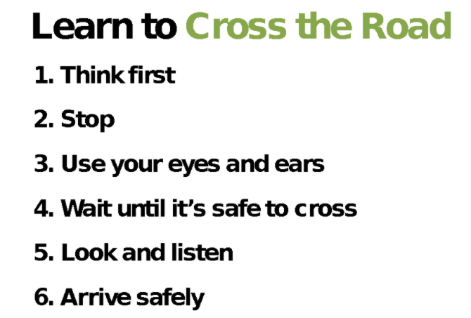

Topic: Healthy Me
Year:3
Spring 2
What should I already know?
What will I know by the end of this unit of work?
Waterloo Primary School – PSHE Knowledge Organiser

