

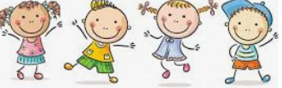

know that different family members carry out different roles or have different responsibilities within the family

Know that gender stereotypes can be unfair

Know some of the skills of friendship (taking turns, being a good listener)

Know some strategies for keeping myself safe online

Know how some of the actions and work of people around the world help and influence my life

Know that I and all children have rights (UNCRC)

Know the lives of children around the world can be different from mine

Unisex

Male/Female

Stereotype

Career

Respect

Social media/Online

Risky

Private messaging

Direct messaging

Global

Fair trade

Equality/Inequality

Climate

Exploitation

Rights/Needs/Wants

Justice

United Nations

Deprivation/hardships

Vocabulary

Different things that can cause conflicts with friends

Family make-ups can be different

Topic: Relationships

Year:3

Summer 1

What should I already know?

What will I know by the end of this unit of work?

Waterloo Primary School – PSHE Knowledge Organiser