

I know what my body needs to stay healthy

I know what can make me feel tense and what can help me to feel relaxed

I know that it is important to use medicines safely

I know how to make some healthy snacks

I know which foods give my body energy

I understand how to keep safe when travelling in a car (wearing a seat belt/being calm and quiet)

I know that rail tracks can be dangerous

I know how to keep safe when near water

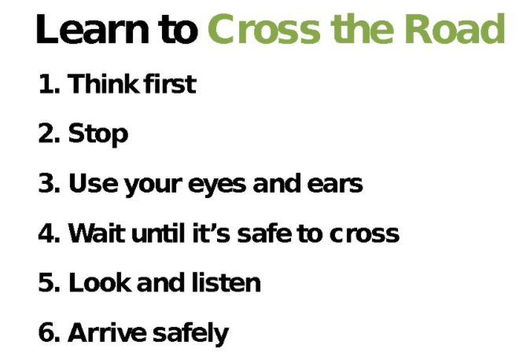

Healthy choices

Lifestyle

Motivation

Relax/Relaxation

Tense

Calm

Dangerous/Safe

Medicines

Balanced diet

Portion

Proportion

Energy

Fuel

Nutrients/Nutritious

Safety Lines:

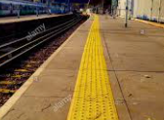

Vocabulary

* My body is special and I need to take care of it
* How to cross a road safely
* How to stay safe in the sun

Topic: Healthy Me

Year:2

Spring 2

What should I already know?

What will I know by the end of this unit of work?

Waterloo Primary School – PSHE Knowledge Organiser