

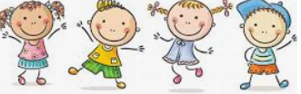

I know that all families are different

I know that families function well when there is trust, respect, care, love and co-operation

I know that there are lots of forms of physical contact

I Know how to say stop if someone is hurting me or making me feel uncomfortable

I know some reasons why friends have conflicts

I know that friendships have ups and downs and sometimes change with time

I know how to use the ‘Mending Friendships’ or ‘Solve-it-together’ problem-solving methods

I know there are good secrets and worry secrets and why it is important to share worry secrets

I know how to give and receive compliments

Similarities/Differences

Relationship

Co-operate

Physical contact

Communication

Acceptable/unacceptable

Conflict

Point of view

Positive problem solving

Good secret/Worry secret

Trustworthy

Honesty

Reliability

Compliments

Appreciate

Vocabulary

* I know which people are special to me and how this makes me feel.
* I know some qualities that make a someone a good friend

Topic: Relationships

Year:2

Summer 1

What should I already know?

What will I know by the end of this unit of work?

Waterloo Primary School – PSHE Knowledge Organiser