
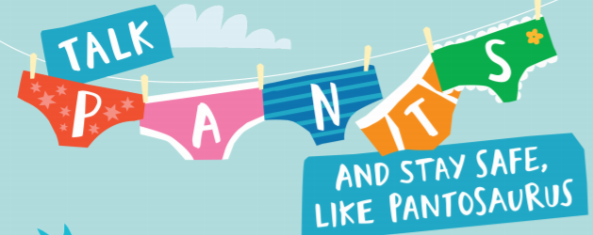
I Know that animals including humans have a life cycle
I Know that changes happen when we grow up
Know that we all grow at different rates and that is normal
I Know who I can talk to if my body isn’t being respected or if I am worried
I know that what is in my pants, my chest and my mouth are private
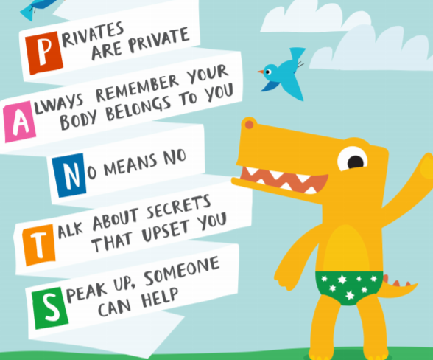

Changes
Life cycles
Baby
Adult/Adulthood
Grown-up
Mature
Male/Female
Anxious
Worried
Excited
Coping
Private body parts

Vocabulary
I know the names of some body parts
I know we grow from babies to adults
I know who I can talk to if I am worried

Topic: Changing Me
Year:2
Summer 2
What should I already know?
What will I know by the end of this unit of work?
Waterloo Primary School – PSHE Knowledge Organiser

