

Safe

Special

Calm

Belonging

Special

Rights

Responsibilities

PSHE Code of Conduct

Rewards

Proud

Consequence

Upset

Disappointed

Vocabulary

* Some things that make me special
* We are all different and special
* What it can look/sound like when people are sad/happy
* Hands can be used kindly and unkindly
* We all have rights and responsibilities in our class
* My views are important
* My choices have consequences
* I am special
* I am safe in my class
* Some behaviours help to make my class a safe place
* I can feel proud

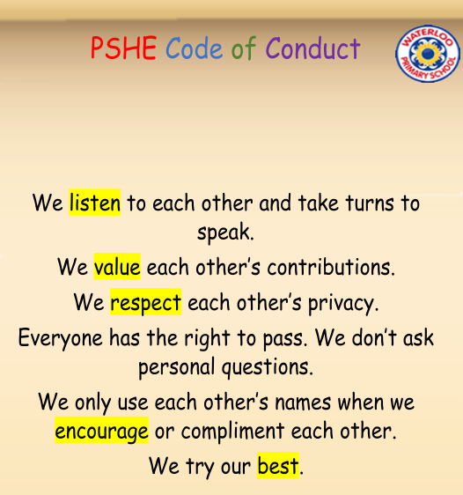

Topic: Being Me in My World

Year:1

Autumn 1

What should I already know?

What will I know by the end of this unit of work?

Waterloo Primary School – PSHE Knowledge Organiser