

* I know what a challenge is
* I know that it is important to keep trying
* I know what a goal is
* I can talk about a job I might like to do in the future

Vocabulary

Proud

Success

Achievement

Goal

Treasure

Goal

Stepping-stones

Process

Team work

Celebrate

Challenge

Obstacle

Overcome

Achieve

Dreams

Goals

What should I already know?

I know how to set myself simple goals

I know how to achieve a goal

I know how to work well with a partner

I can spot obstacles which may make achieving my goal difficult

I know who and what can help me to overcome obstacles

I know I can overcome some obstacles and how this feels

I know how I learn best

I know I can celebrate my achievements

I can store things that I am proud of in my internal treasure chest.

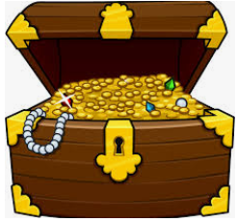

Topic: Dreams and Goals

Year:1

Spring 1

What will I know by the end of this unit of work?

Waterloo Primary School – PSHE Knowledge Organiser