

* I know how to say no to strangers
* I know what to do if I get lost
* When and how to wash my hands
* I know some names of body parts
* I know that sleep/exercise/healthy foods are good for me

Vocabulary

Healthy/Unhealthy

Balanced

Exercise

Sleep

Choices

Body parts

Toiletry items (toothbrush, shampoo, soap)

Hygienic

Safe Medicines

Trust

Green Cross Code

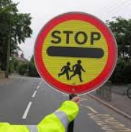

Germs

Illness/disease

I know some ways to keep healthy

I know how to make healthy lifestyle choices

I know how to keep myself clean and healthy

I know that germs can cause disease / illness

I know that household products, including medicines, can be harmful if not used properly

I know that medicines can help me if I feel poorly

I know how to keep safe when it is sunny

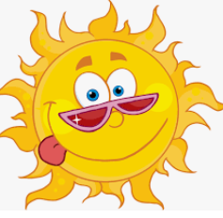

I know how to keep safe when crossing the road

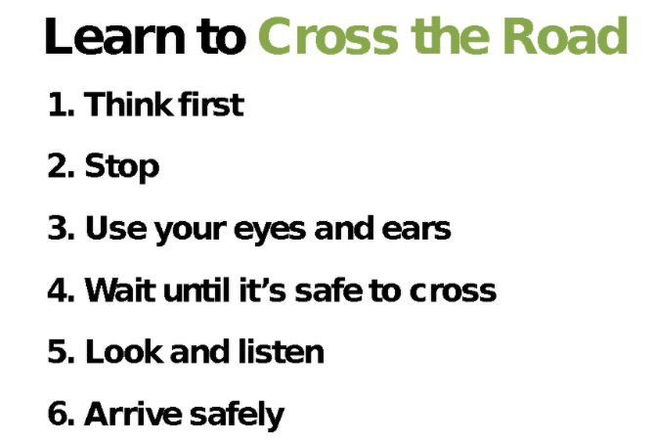

I know different people who can keep me safe

Topic: Healthy Me

Year:1

Spring 2

What should I already know?

What will I know by the end of this unit of work?

Waterloo Primary School – PSHE Knowledge Organiser