

* I know what family is and that different people in families have different jobs (responsibilities)
* I know when friendships are working well and I know some ways to be a good friend

Family

Belong

Qualities

Caring/Sharing/Kind

Greeting

Touch/Feel

Texture

Like/Dislike

Community

Confidence

Praise

Skills

Self-belief

Appreciate

Vocabulary

I know that all of our families are different

I Know that there are lots of different types of families

I Know that families can give feelings of belonging, love and care

Know some qualities that make a good friend

I know that physical contact can be used as a greeting

I know about the different people my school community and how they help us

I know who to ask for help in the school community

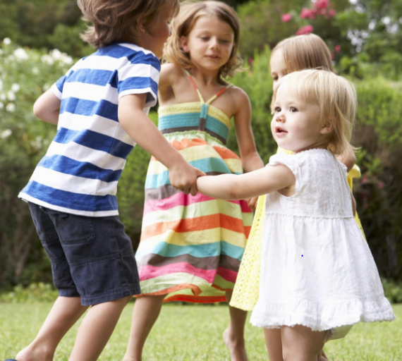

I know that violence at home, in school or in the community is unacceptable

Topic: Relationships

Year:1

Summer 1

What should I already know?

What will I know by the end of this unit of work?

Waterloo Primary School – PSHE Knowledge Organiser