

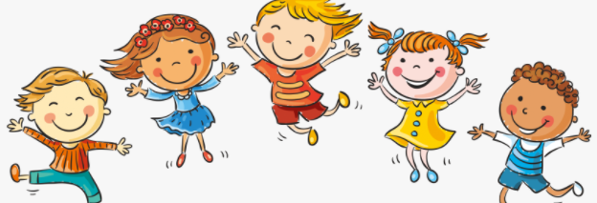

I know that life cycles exist in nature

I know that aging is a natural process including old-age

I know that some changes are out of our control

I know how my body has changed from when I was a baby and that it will change more as I get older

I know some physical differences between male and female bodies

I know the correct names for private body parts and when it is appropriate to talk about them

I know that private body parts are special and that no one has the right to hurt them

I know there are different types of touch and that some are acceptable and some are unacceptable

I Know who I can talk to if my body isn’t being respected

Change

Grow

Cuddle, Hug, Squeeze,

Control

Life cycle

Respect

Appearance

Physical

Baby, Toddler, Child, Teenager, Adult

Independent

Timeline

Freedom

Male/Female

Private body parts: vagina, penis, testicles, vulva, anus

Acceptable/Unacceptable

Comfortable/Uncomfortable

Vocabulary

* Physical differences between boys and girls
* Which body parts are private and the correct names for them

Topic: Changing Me

Year:2

Summer 2

What should I already know?

What will I know by the end of this unit of work?

Waterloo Primary School – PSHE Knowledge Organiser